BL-22, Grade II

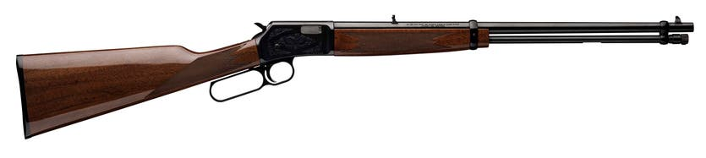

Overview
Take a step up to Grade II. The BL-22 is something that is often found on a wish list. You may ask why? Simply because it is the premier lever action 22 of all time. It gained this distinction for several reasons. Superb quality, solid function and the speed of 33-degree lever throw. The scroll engraved receiver, checkered walnut stock and the added touch of a classic Browning gold-colored trigger also set it apart. There are other lever-action 22 rimfire rifles available, but no other has the features, reliability, quality and accuracy of the BL-22.
All the features, fast. Speaking of fast and features, the highlight of the Grade I BL-22 is the short 33° lever throw that makes cycling faster and easier for shooters. The easy to load tubular magazine holds any combination of 22 short, long and long rifle ammunition, all of which are on the menu for the BL-22. The magazine tube -- once loaded -- locks securely in place. The BL-22 features quality muzzle to butt that rivals other Browning firearms.
Steel receiver, very nice. From the machined steel receiver to the fit of the finely finished wood, these superb rifles are Browning's through and through. Bring one along the next time you head into the field on a varmint hunt or just to roll a few tin cans.

BL-22 Grade II Features
- Blued receiver finish
- Scroll engraving
- Gloss finish American walnut stock with traditional point checkering pattern
- Tubular magazine

BL-22 Features
- Grooved receiver ready for optics
- Receiver machined from solid steel
- Smooth, quick-cycling 33° lever throw
- Trigger travels with the lever to help prevent finger pinch
- BL-22 fires 22 Short, Long and Long Rifle ammunition
CALIBER • BARREL LENGTH
- 22 S L LR • 20"
Item Number024101103 | UPC023614025481
Caliber22 S L LR | Barrel Length20"
Overall Length36 3/4" | Length of Pull13 1/2"
Drop at Comb7/8" | Drop at Heel1 1/2"
Weight5 lbs 0 oz | Magazine Capacity15
Twist Rate16" | Barrel FinishPolished Blued
Stock FinishGloss | Wood GradeGrade I
Receiver FinishPolished Blued | Chamber FinishPolished
Barrel MaterialSteel | Barrel ContourLight Sporter
Stock MaterialBlack Walnut | Recoil PadPlastic Buttplate
CheckeringCut 20 LPI | Sling Swivel StudsNone
Receiver MaterialSteel | Trigger FinishGold Plated
Bolt Slide FinishBrushed Polish | Magazine TypeTubular
Trigger MaterialAlloy | Trigger Guard MaterialSteel
Trigger Guard EngravingBuck Mark in Gold | Drilled and Tapped for ScopeNo

